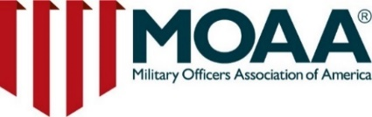**San Francisco**

**Fleet Week Special event**

**Aboard the U.S.S. Jeremiah O’Brien**

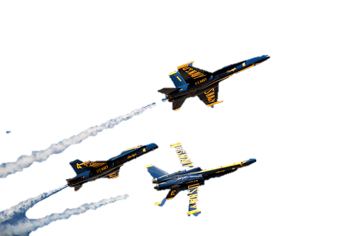Join us for a special day during **San Francisco Fleet Week** to honor the brave men and women of the United States Armed Forces while supporting our future leaders!

* **Aboard: The** [**U.S.S. Jeremiah O’Brien**](https://www.ssjeremiahobrien.org/)**,** Pier 35 North, The Embarcadero, San Francisco, CA 94133
* **Date: Thursday, October 10th, 2:00 p.m. – 5:00 p.m.**
* **Cost**: **Early Bird Special $90 if purchased by September 15th**
* Includes Access to the entire ship, including museum, beer, wine, heavy appetizers and non-alcoholic beverages.
* **Credit Card:** <https://www.ticketleap.events/tickets/alamedamoaa/fleetweek>
* **PayPal** to [ramonachavez@comcast.net](mailto:ramonachavez@comcast.net) Send as a Friend.
* **Checks** to: Alameda Chapter MOAA. Mail to CAPT Warren McDonald; 1430 Wendy Way Menlo Park, CA 94025. Please note for Alameda MOAA Fleet Week Event
* **Contact**: Ramona Chavez, [info@alamedamoaa.org](mailto:info@alamedamoaa.org); 925-963-2711

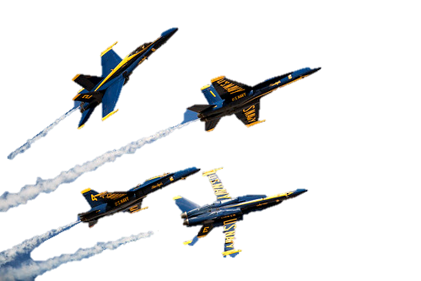**Hosted by:** [Alameda Chapter](http://alamedamoaa.org/Home) of the Military Officers Association of America (MOAA)

Enjoy a **preview of the weekend’s airshow**—featuring the thrilling **US Navy Blue Angels**—in a more relaxed atmosphere, away from the weekend crowd, and at a lower cost. Explore visiting Navy ships and experience Fleet Week without the hustle.

Your attendance will directly support the Alameda MOAA's ROTC Scholarship Fund. Every year, we raise funds to provide scholarships to deserving ROTC cadets in the Bay Area, helping to prepare our next generation of leaders.

**Event Highlights:**

* **Airshow Preview:** Featuring the US Navy Blue Angels
* **Support Our ROTC Cadets:**  Fundraising for scholarships
* **Relaxed Atmosphere:** Escape the weekend crowds
* **Contribute to a Worthy Cause:** Donations are tax-deductible

**Purchase your ticket today** and help us make a difference while enjoying a spectacular show!

We hope to see you there!

[MOAA](https://www.moaa.org/) is a nonprofit military and Veterans association, dedicated to upholding a strong national defense and supporting our nation’s commitment to servicemembers, Veterans, and their families. As a registered nonprofit, contributions made to MOAA are tax-deductible under IRC Section 501(c)(19).



**AlamedaMOAA.org**